Holy Rosary Athletic Program

Table of Contents

- Mission Statement p 3

- Fall Sports p.p. 5- 8

- Winter Sports p.p. 9 - 10

- Spring/Summer Sports p.p. 11 - 13

- Parochial Athletic Association p.p. 12 - 14

- Athletics at a Glance p. 15

- Sports Pilot p.p. 16 - 20

Mission Statement

The mission of the Holy Rosary School Athletic Department is to provide an athletic program that extends the learning experience beyond the classroom. The Athletic Department strives to develop student-athletes physically, socially, and mentally; encourage leadership, responsibility, teamwork, and sportsmanship; and provide the opportunity for students to develop their potential as athletes in sports appropriate to their age level.
Beliefs
- Students are our highest priority.
- Positive parent support and involvement enhance the growth of the athletic program.
Goals
- To provide life lessons.
- To instill the desire to excel through preparation and hard work.
- To instill pride in the school and parish.

Coaching Philosophy
- Wins and losses do not determine the value of a Coach.
- Coaching methods geared towards player’s needs, ability level and learning style.
- Coaching involves building teamwork and identifying a role for each player on the team.
- Communication and mutual respect among coaches, parents and athletes provide the foundation of a successful athletic program.
- The Right Attitude Means Success = RAMS
Team Selection Process
- 3K-4th grade athletes will be split into teams evenly by talent. There will be an open gym date followed by a “draft” lead by the coaches and athletic director.
- 5th-8th grade sports are in competitive leagues. The athletes will be split by talent creating an A and B team.
  - In the case that the registration numbers are low, the athletic director may allow a 5th/6th combo team and a 7th/8th combo team
  - In the case that the registration numbers are low, the athletic director may extend the sign up deadline.

Fall Sports

Football
Holy Rosary offers Football for 5th through 8th grade boys, one team for the 5th & 6th grade boys and one team for the 7th & 8th grade boys. The grades are split because of height and weight rules by the Parochial Athletic Association (PAA). Both teams normally play 8 games from late August until the middle of October. Practices start on the first Monday of August, unless the league decides to change it due to how the calendar lines up.
Football practice is 5 days a week for the first 3 weeks. Practice time is subject to the coach’s availability but is usually 5:30pm to 7:30pm.. Majority of the games will be played on Thursdays. Home games are played at CBHS. The practice schedule will then be adjusted to fit within the game schedule, which typically includes 4 practices and a possible 5th practice without pads.
Holy Rosary will do a weigh-in before the first practice and give out the equipment and uniforms. Holy Rosary provides: helmet with mouth guard, shoulder pads, pad girdle, practice uniform, game uniform and knee pads. Parents are required to return everything in the list with these exceptions: pad girdle and mouth guard.
Parents are required to provide socks, cleats and water at every practice and game. We will have water at all home games, but still bring an individual jug of water just in case.
Our coaches are all volunteers. They all have experience playing football. All the coaches have been through a background check and the Virtus Program, Protecting God’s Children. Please feel free to ask the coaches questions before or after practice or games. They will provide contact information to you.
Number of Student Athletes per Team: Max 25 Min 16
Heat Policy – All PAA Teams are required to check the Heat Index (H.I.) before practice or a game. We check it 15 minutes before both. If the H.I. is at 104 degrees or above we cannot practice outside. We will practice in the gym. Once the H.I. drops below 104 we will go back outside. Holy Rosary uses a tool that tells us the H.I. and we use a special app to also evaluate the H.I. When the H.I. is high the coaches typically break for water every 15-20 minutes. We have an EMT at some practices and at all games.

Volleyball
Holy Rosary offers Volleyball for the 5th through 8th grade girls. 5th and 6th grade girls will be divided into a varsity and JV division. 7th and 8th grade will also be separated into a varsity and JV division.
Volleyball practice begins on August 4th and the games will start in late August and run through the middle of October ending with a Tournament for all teams. Holy Rosary will host one tournament.
Practice will be decided upon by the coaches. Practice times will be between 3 pm and 9 pm and typically last an hour and a half.
Holy Rosary provides a uniform jersey. Parents are to provide knee pads, black spandex shorts, volleyball shoes and socks. The team will pick out socks and parents will contribute to the purchase. If, Holy Rosary has the funds we will buy socks for everyone. That will be decided in August.
Number of Student Athletes per Team: Max 9-10 Min 6

Golf
Holy Rosary offers Golf for 5th, 6th, 7th & 8th grade Boys and Girls. Meets include 3 schools competing at the same course. If we have more than the minimum number of members for a team the rest of the players will play in the back of the field and their scores will not count toward the official score. The coach will rotate the players so everyone has a chance to compete at the Meet.
Holy Rosary provides a golf shirt when funds allow. Parents are required to provide the golf clubs and shoes. Tennis shoes are allowed.
Number of Student Athletes per Team: Min 4 Boys 2 Girls

Soccer 1st – 8th Grade
Holy Rosary offers soccer for boys and girls in the 1st through 8th grades. Teams are comprised of 1st – 2nd graders, 3rd – 4th graders, 5th – 6th graders and 7th – 8th graders depending upon the number of registered players. Soccer practice starts in early August with games starting in September. The season will continue through the month of October. Games will be played on Saturdays and Sundays at respective fields.
Practice times will be determined by the Coach. Typically a team will practice twice a week for an hour for 1st - 2nd grade teams and an hour and a half for other teams. Practices are not held at Holy Rosary but rather at local parks in East Memphis, i.e. Marquette Park, Sea Isle Park, etc.
Holy Rosary provides the uniform jersey and shorts. Socks are provided if the funds allow. Parents are required to provide shin guards and soccer cleats.
The PAA has recently made changes to the number of athletes on the starting lineup. PAA used to allow 9 players to start a game. Beginning with the 2014 season that number has changed to 7 for the 1st – 4 graders and 9 for the 5th – 6th graders. This allows for players to have more play time and coaching opportunities.
Numbers of Student Athletes per Team: 1st – 4th grade league: Max 12 Min 7 5th – 6th grade league: Max 16 Min 9
7th – 8th grade league: Max 16 Min 11
Micro Soccer
Holy Rosary offers micro soccer to boys and girls in PreK 4 and K grades. This is not a PAA League Sport. Micro Soccer is run by Holy Rosary which means we only play each other during a 6 week season. This allows us to give the kids an introduction to soccer without having to worry too much about competition.
Micro Soccer is setup to be 4 on 4 per game. All games are played on the field at Holy Rosary by the play ground. All coaches receive a practice plan that includes basic skills which translate into a game plan.
Practices start on August 18th and the games will start on the first Saturday after Labor Day and will run through the middle of October. Games are played at Holy Rosary on Saturday mornings at 9am or 10 am. Practices are held at Holy Rosary and other local parks in East Memphis. A practice schedule will be created so that all teams get the opportunity to practice on the field at Holy Rosary.
Holy Rosary provides a t-shirt and shorts. When funds allow we also provide socks.
Parents are required to provide shin guards, cleats and socks if Holy Rosary does not provide.
Number of Student Athletes per Team: Max 8 Min 6
Cross Country
Holy Rosary offers cross country for boys and girls in the 3rd – 8th grades. Runners are divided into divisions: 3rd-5th running 1 mine and 6th-8th running 2 miles.. Meets are held at Shelby Farms typically on Wednesday evenings. Meets start in September and end in October.
Practice begins August 4th and is held after school during the week at Marquette Park. Holy Rosary provides the uniform and shorts. Parents are required to provide shoes and water.
PAA Heat Index Policy: When the H.I. rises to 104 practice is moved inside the gym. Holy Rosary has a device that will detect the H.I.
There is No Max or Min of runners allowed. Typically there are 30-35 on the team and everyone runs during the Meets.

Cheerleading 7th and 8th Grade
Holy Rosary offers cheerleading for girls in the 7th – 8th grades. Cheer practice begins in early May and continues into June. All cheerleaders will attend Cheer Camp which is scheduled in June. After Cheer Camp, practice resumes in August to get ready for the football games. Practice continues into October in preparation for the PAA Cheerleading Meet. This Meet consists of 3-4 schools and each routine is scored by judges.
The coach chooses the cheer uniform and camp clothes which the parents are required to purchase or fundraise to offset the cost. This information is provided by the coach.
The team will continue to cheer into December and January for the 7th-8th grade basketball teams.
There is No Max or Min of cheerleaders allowed. Typically there are 30-35 on the squad.

Winter Sports
Basketball
5th – 8th Grade
Holy Rosary offers basketball for boys and girls in the 5th through 8th grades. 5th, 6th, 5th - 6th combo, and 7th - 8th combo grade teams will compete in the Parochial Athletic Association (PAA). This year the 7th and 8th grade teams will compete in the Shelby 78 League.
Practice will begin on the first Monday in November and the games will begin after Thanksgiving. There are multiple Tournaments throughout the season including the Turkey Shoot in November, the MAM or Blue Streak Tournament at Christmas and the Year End Bishop’s Tournament or the Year End Shelby 78 Tournament.
Holy Rosary provides a uniform jersey and shorts. Practice times are scheduled by the coaches and occur after school until 9pm at night. The season games will start around December 1st and will run into February with tournaments.
Parents are required to provide basketball shoes. Basketballs are given to coaches and you are not required to buy a ball for your student athlete.
Number of Student Athletes per Team: Max 12 Min 8
Charlie Brown Lucy Basketball (CBLL)
Holy Rosary offers CBLL Basketball for girls and boys in the 1st through 4th grades. Teams are divided into leagues for example, 1st – 2nd Girls, 1st – 2nd Boys, 3rd – 4th Girls and 3rd – 4th Boys. Practice for CBLL will begin in early February. The start of practice is determined by the end of the 5th-8th grade seasons. Games will begin in late February. Practice time is decided upon by the coach and practice will be anytime from 3 pm until 8 pm.
Games are played on Saturdays and Sundays. Games are played at Holy Rosary and surrounding Catholic Schools. Some teams at competing schools may be Co-Ed due to low turnout. Holy Rosary provides a reversible uniform jersey and shorts. Parents are required to provide tennis shoes for your child.
Holy Rosary will host a tournament for the teams in the 3rd and 4th Grade Boys and Girls divisions. The weeklong Michael Fletcher Classic Tournament is held during the season typically after Spring Break.

Number of Student Athletes per team: Max 10 and Min of 7

Swimming, 5th – 8th Grade
Holy Rosary offers swimming for boys and girls in the 5th through 8th grades. Practice will begin in October and the first meet is in November. The coach will announce details of practice and meets when they are available. Practice is held at the Nuber YMCA on Quince and transportation from school to the YMCA will be discussed at the first team meeting.
Holy Rosary does not provide a uniform for the swim team members. Parents are required to provide a swimsuit and cap.
Number of Student Athletes per Team: Max None Min 1

Spring Sports
Baseball & Softball
5th – 8th grades
Holy Rosary provides baseball & softball for students in the 5th – 8th grades. We will play in the PAA league. Practice begins in February with the games beginning in March. Games are played on Tuesdays and Thursdays. Coaches create the practice schedule which are typically anytime between 3 pm and sundown.
Holy Rosary provides a uniform jersey, pants, belt and hat. The coaches receive an equipment bag with bats, balls, catchers gear, batting helmets and some gloves.
Parents are required to provide a glove and cleats.
Uniform Pant Options: Parents may purchase uniform pants when the following requirements are met:
- All parents agree to cover the entire cost of the pants.
- All players must wear the same style/color of pants.
- The pants’ color must match the jersey color scheme.
- The parents must receive written approval from the Athletic Director prior to purchasing the pants.
Number of Student Athletes per Team: Max none Min 10, 9 players must be present to begin a game.
Charlie Brown and Lucy Baseball & Softball (CBLL)
Holy Rosary provides CBLL baseball & softball for students in the 1st – 4th grades. Practice begins in late April with games running from May through June.
Coaches will help the Athletic Director with sorting out players for each team. When necessary we are doing skills assessments so each team has a balanced amount of kids to be able to compete and have fun. Our program is about introducing the students to the sport.
Holy Rosary provides a hat or visor, uniform t-shirt and pants.
Parents are required to provide cleats and a glove. The pants provided do have belt loops but no belt is provided.
Number of Student Athletes per Team: Max None Min 10

Tee Ball
Holy Rosary provides tee ball for boys and girls in the PreK 4 and Kindergarten grades. Students must be enrolled at Holy Rosary to participate. Practice begins in late April and games begin in May and end in June. Games are on Friday nights at Holy Rosary on the field by the playground.
Practices are scheduled by the coaches and typically occur around 5:30 pm several times a week.
Holy Rosary provides a uniform t-shirt and hat or visor. Parents are required to provide a glove, tennis shoes and shorts.
The coaches are given an equipment bag with bats, balls, tee and batting helmets. Parents can purchase a batting helmet and/or bat if you want. Please label it with your child’s name.
At the end of the season, the Men’s Club sponsors a picnic for the players and families which includes hot dogs, chips, dessert and presentation of trophies by the coaches. Parents are asked to supply drinks and chairs/blankets.
Number of Student Athletes pet team: Max none Min 9

Parochial Athletic Association (PAA)

PHILOSOPHY STATEMENT

The athletic programs administered by the Catholic Diocese of Memphis are based on the premise that young adolescents between the ages of 10 and 15 have special spiritual, intellectual, emotional, social and physical needs, which are best met in an environment, which is distinct from not only elementary school but also high school athletic programs. The Parochial Athletic Association (PAA) offers to its participants a sense of belonging and creates a climate resulting in young people who work toward developing strengths and improving weaknesses. This atmosphere allows young adolescents to experience positive growth and development now and in the future. Athletic programs, which are based on the teachings of Christ and rooted in the teaching of His Church, provide avenues for learning which foster positive attitudes about self and others. The PAA also offers for the younger children (school age – grade 4) a league that offers soccer, basketball, baseball and softball – this league is known as the Charlie Brown/Lucy League (CBLL).

Within the five principal areas of maturation typifying the young adolescent years: spiritual, intellectual, emotional, social and physical, administrators and coaches of PAA programs work harmoniously with church/school leaders and teachers and utilize a variety of instructional techniques. The instructional aspects of PAA programs are participant-centered and specifically geared to meet individual player needs. No interested adolescent is “cut” from team, i.e. denied participation on a church/school-sponsored team in a PAA league. Furthermore, all PAA programs and related activities receive equal planning and support. The respect for the human dignity of each participant is at the forefront of all decision-making.

The PAA programs are the instruments by which young adolescents develop the fundamental skills and basic strategies of the games or activities in which they participate. During the ages of 10 and 15, adolescents want to explore all extra-curricular possibilities in order to determine which ones they are most interested in and most proficient in. Winning should not be the primary goal of PAA athletics. Winning is less important than preparing the athlete to win. Young adolescent athletes should be rewarded for personal bests and positive efforts, regardless of game outcomes. If the emphasis on winning or being the best is introduced too early or too strongly, the emotional balance of this age group is upset. Administrators and coaches in the PAA must have an understanding of adolescent development phases, enjoy working and having fun with youngsters, and respect the uniqueness of each of their charges. Likewise, administrators and coaches in the PAA must be committed to enhancing the growth and development of players, to offering specialized and proper instruction, and to working as a part of the church/school athletic programs teams. They must foster trust, dignity, consistency, fairness, and add a degree of humor to their endeavors.

The CBLL league is structured in such a way that all players who are eligible should receive equal playing time in each game. Scores are kept but the emphasis is not on winning, but is on learning the basic fundamentals of the game, sportsmanship and the advantages of being a member of a team. League standings are not kept in this league and there are no team awards presented.

GOALS OF THE PAA/CBLL

Spiritual
- To appreciate and actively support the inherent ties between church, school, and the sponsored activities.
- To embrace the challenge of working for the development of a personal relationship with Christ for each participant

Intellectual
- To utilize and foster the development of proper communication skills, diverse teaching strategies, and necessary game skills

Emotional
- To provide opportunities for each adolescent participant to explore his/her identity, values and abilities

Social
- To model respect for human dignity
- To promote the ideals of sportsmanship
- To ensure the development of teamwork

Physical
- To acquire a keen understanding of adolescent development & adolescent needs
- To accept responsibility for guiding children through subsequent emotional changes associated with physical development
- To hold the bodily safety

THE ROLE OF SPORTS IN CATHOLIC SCHOOLS

Catholic schools are excellent because they are holistic in nature, i.e. they educate the whole person. In addition to the spiritual and intellectual dimensions, there is a need for the physical development of each student.

Pope John Paul II, an avid sportsman himself, believes that “sports can and must contribute to the integral development of the human person.”

Catholic elementary schools in the Diocese of Memphis support sports programs as part of their ministry to their students. Sports promote good health, strong self-esteem, loyalty, fair play, generosity, friendship, cooperation and other positive values.

First and foremost in the minds and hearts of all those involved in Catholic school sports programs should be the interest of the young people under their care. Every effort should be made to place competitive sports in a Christian perspective. The desire to win at all costs should be discouraged. Violence on the field, poor sportsmanship, excessive negative reinforcement, and other such inappropriate behavior should be eliminated. The emphasis should be on insuring positive reinforcement, skill development, teamwork and good sportsmanship.

It is the goal of the diocesan athletic director’s office to insure that the sports programs reflect the highest principles and teachings of the Catholic Church.

Holy Rosary Sports Registration, At a Glance Info

Sport | Grade | Season | Registration Period | 1st day of practice | Games/Meets | Registration Fee
Football | 5th-8th | Fall | May 1st-July 15th | August 4th | Late August – Middle October | $85
Volleyball | 5th-8th | Fall | May 1st-July 15th | August 4th | Late August – Middle October | $60
Golf | 5th-8th | Fall | May 1st-July 15th | August 4th | Late August – Middle October | $50
Soccer | 1st-8th | Fall | May 1st-July 15th | August 4th | Late August – Middle October | $60
Micro Soccer | 4K-K | Fall | May 1st-July 15th | Mid-August | 1st Saturday in September – Middle October | $40
Cross Country | 5th-8th | Fall | May 1st-July 15th | August 4th | Late August – Middle October | $60
Cheerleading | 5th-8th | Fall & Winter | TBD | May | Attend home games for football and basketball. Cheer meet is in October. | TBD
Swimming | 5th-8th | Winter | Aug 11th – Sept 12th | October | October - January | $60
Basketball | 5th-8th | Winter | Sept 15th – Oct 15th | 1st Monday in November | After Thanksgiving – Early February | $60
CBLL Basketball | 1st-4th | Winter | Dec 1st – Jan 9th | TBD by end of 5th-8th league | Late February – End of April | $60
Baseball | 5th-8th | Spring | Jan 1st – Feb 1st | February | March – Early May | $60
Softball | 5th-8th | Spring | Jan 1st – Feb 1st | February | March – Early May | $60
CBLL Baseball | 1st-4th | Spring | March 15th – April 15th | Late April | May – June | $60
CBLL Softball | 1st-4th | Spring | March 15th – April 15th | Late April | May – June | $60
T-Ball | 4K-K | Spring | March 15th – April 15th | Late April | May - June | $40
Track | 7th/8th | Spring | March 15th-april 1^{h} | Late April | May-June | $60

Sports Pilot
Registration Website
Sports Pilot is a web based registration program that Holy Rosary uses to register student athletes and coaches. The system allows parents and coaches to create an account and add demographic information along with cell phone and home phone numbers.
The Athletic Director uses Sports Pilot to create programs so the registration process is efficient for all users. We also use Sports Pilot to organize leagues and teams which are the foundation of our athletic program. Using this system provides the Athletic Director a tracking mechanism for all information entered into the site from payments made to emergency contacts for students.
A link to the Sports Pilot website is located on the Holy Rosary website at www.holyrosarymemphis.org By going to the schools website and clicking on any Athletics page you will find a link that says “Athletics Registration Website”. That will bring you to this page.
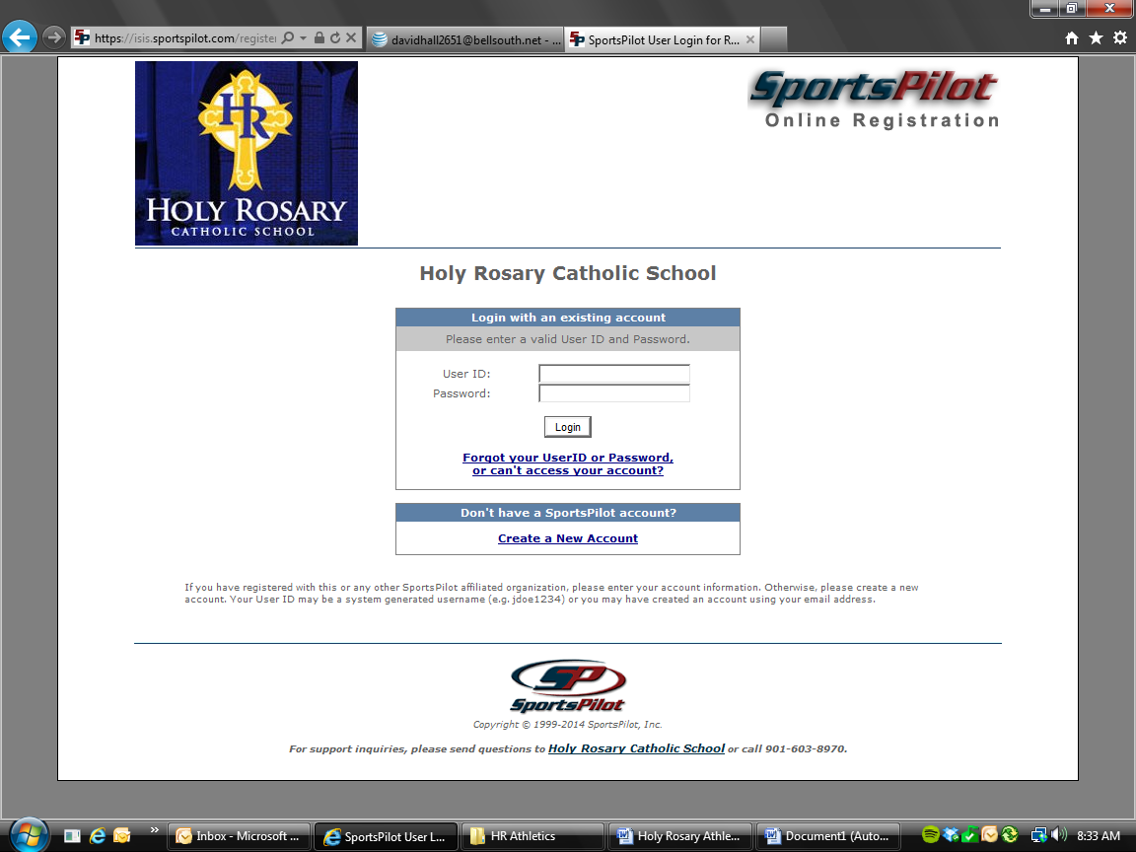
New users to our system are required to click the Create a New Account button. This will allow you to create a username and password and fill out the demographic information about your family. Once you have logged into the system, continue the process by clicking the “Add Parent” or “Add Child” buttons to add all family members.

When you are registering your child for a sport it is mandatory to fill out all fields in the registration process. By doing so, we know your child’s uniform sizes, emergency contacts and other contact phone numbers. This information is used to distribute uniforms and to send email alerts regarding rain outs and/or schedule changes.

When it is time to register you will click the “Register Coach” button to the left of the parent’s name if you would like to be a volunteer or the “Register Player” button to the left of the child’s name to register him/her for a sport.
The screen below is what will appear after clicking either the “Register Coach” or “Register Player” button. Select the sport your child wants to play.
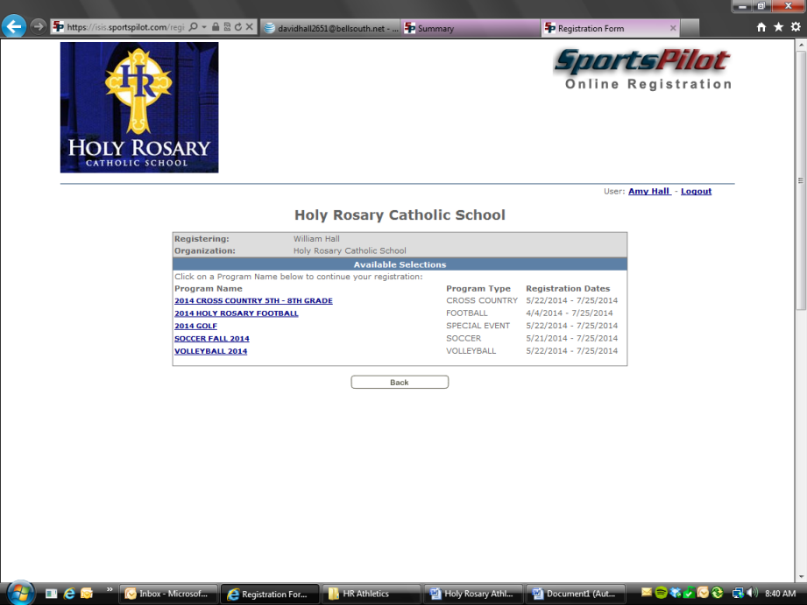

A term of Service Agreement is the next screen in the registration process. This page has two purposes. The first purpose is the Liability Release for your child. This grants Holy Rosary protection from lawsuits from parents for player injury. The second purpose is an agreement that all users apply by Sports Pilots policies for this website.
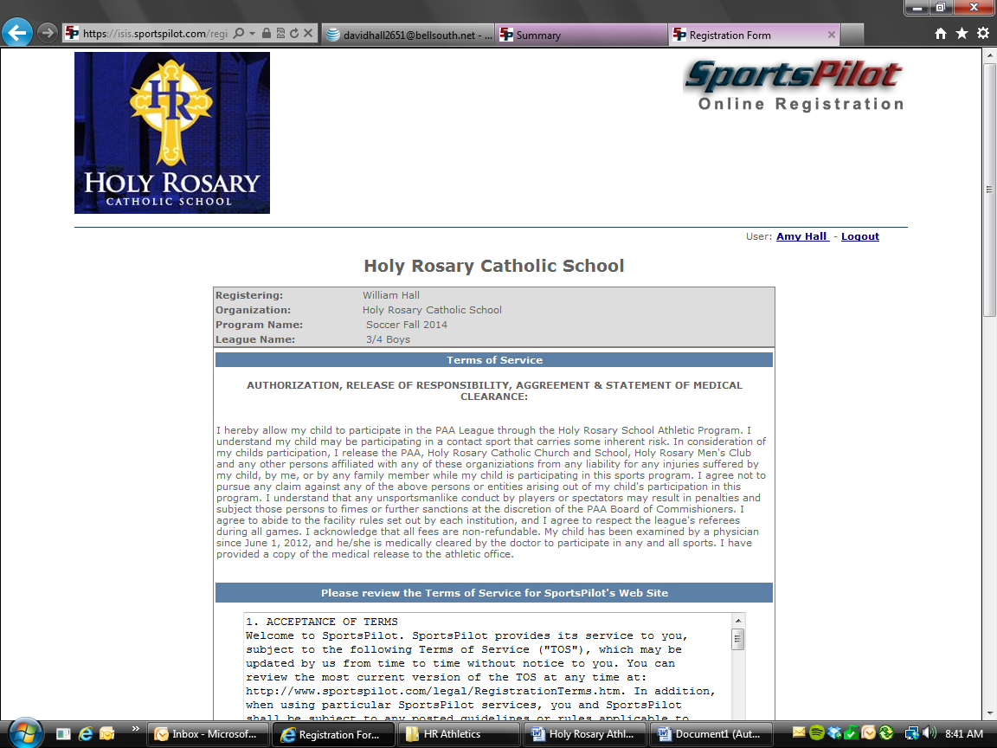

This page is critical. Please don’t skip over it. This is your opportunity to update vital information about your child like size for uniforms, grade and age of your child and emergency contact information.
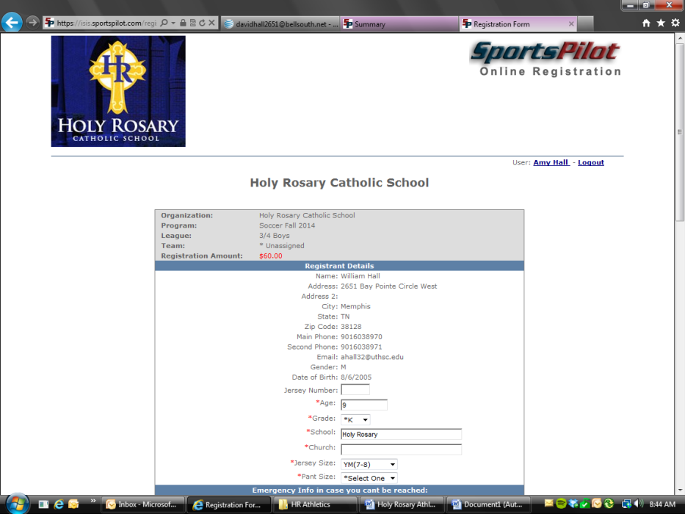
This screen tells us that you have almost finished the registration process. The box on the top right is the checkout box. That is for payment with credit card or to pay by check later. It is vital to finish this section so your child’s registration information is placed in the correct status on the admin side so she/he makes it onto a team.
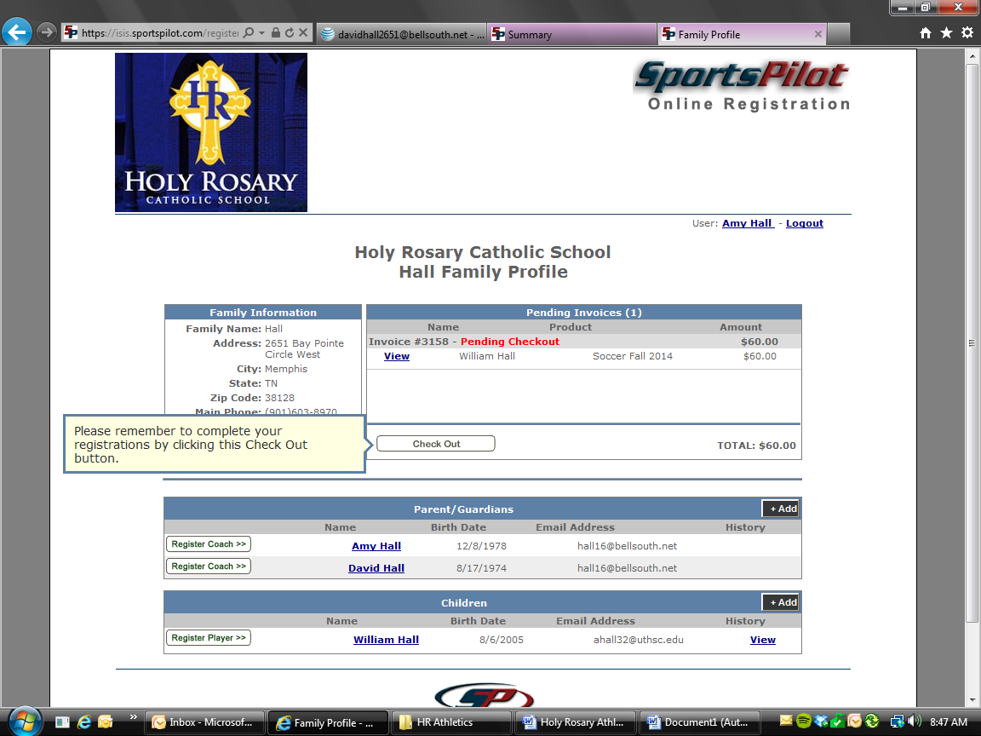
The screen below came up when I clicked on my son’s name, from the previous screen shot. This lets me see his demographic information. On the email field it is important to put both parents’ email address so that everyone gets the communication from the coach or from the Athletic Director.
Here is the format to add two email address to that field: emailname@emailprovider.com; emailname2@emailprovider.com
Make sure and add the semicolon between the email addresses so that everyone gets the information. Feel free to add more than 2 as long as a semicolon is between the email addresses.
