Before completing awareness training online, all participants first register with VIRTUS Online. Please click on the VIRTUS link to access the VIRTUS Registration page:  https://www.virtusonline.org/virtus/reg_2.cfm?theme=0&org=18858  Or, please register by going to www.virtus.org and click on ‘First Time Registrant’ and selecting the Diocese of Memphis from the dropdown menu. | 
Create a user ID and a password you can easily remember.  This is necessary for all participants. This establishes your account with the VIRTUS program. If your preferred user ID is already taken, please choose another ID. We suggest the use of email addresses as usernames.  Click Continue to proceed. | 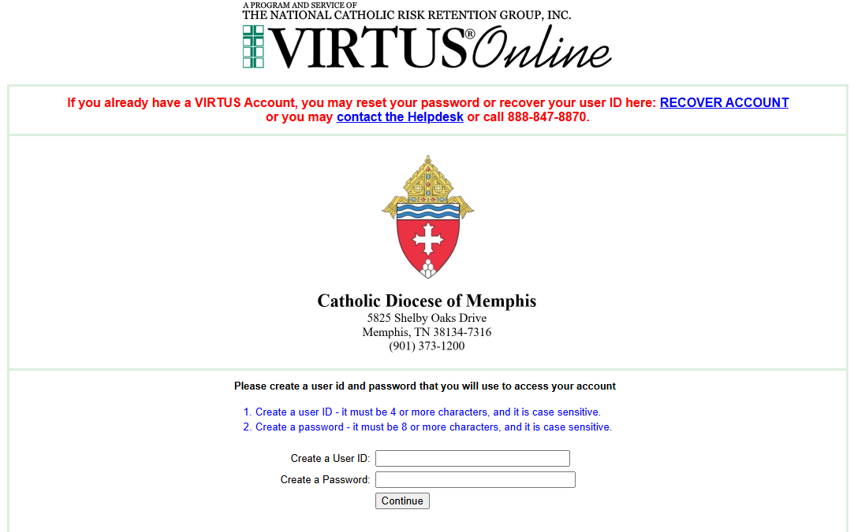
Provide all the information requested on the screen.  Several fields are required, such as: First, Middle & Last Name, Email address, Home Address, City, State, Zip, and Phone Number.  (Note: Do not click the back button or your registration will be lost.)  Click Continue to proceed.  If you do not have an email address, consider obtaining a free email account at mail.yahoo.com, or any other free service. This is necessary for your VIRTUS Coordinator to communicate with you. | 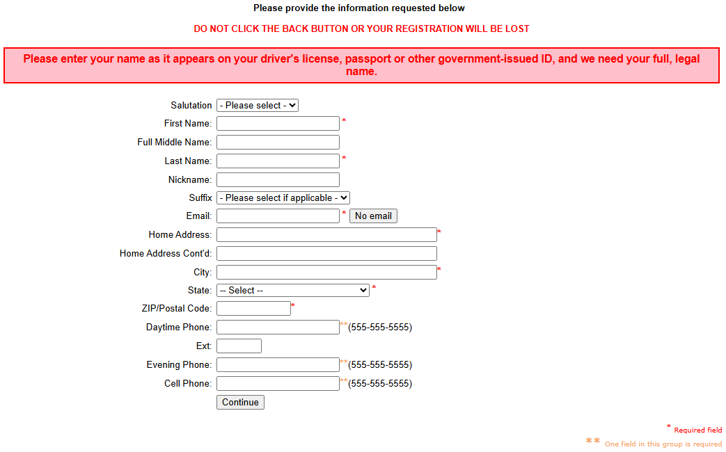
Select the PRIMARY location where you work or volunteer by clicking the downward arrow and highlighting the location.  Click Continue to proceed. | 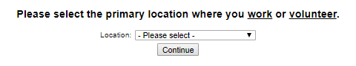
Your selected location(s) are displayed on the screen.  Please select from the role/description that applies to your position.  Additionally, enter your title in the box provided that best describes your role within your location.  Click Continue to proceed. | 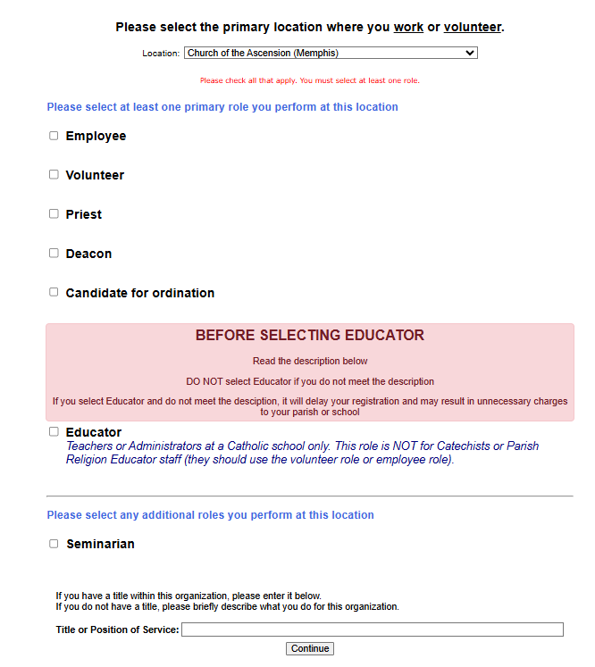
Please select Yes if you are associated with any additional locations, or please select No to continue. | 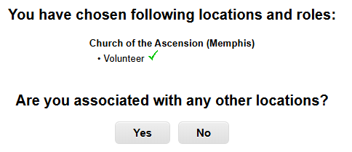
Answer the questions and click on ‘Continue.’ | 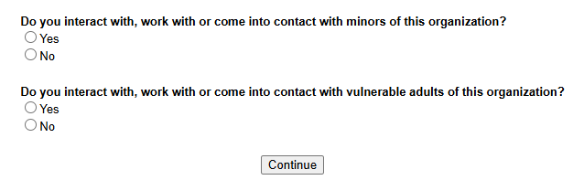
Please review the following document on the screen and respond:  - Code of Conduct  To proceed and acknowledge each document, please Confirm by clicking on: “I have read and understand this document.” and enter your full name and today’s date.  Click on Continue. | 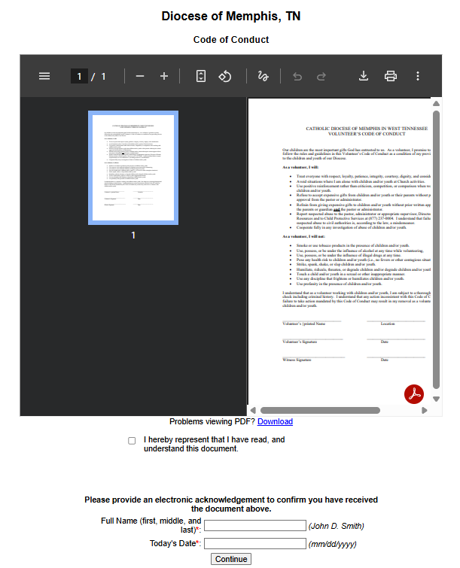
Answer the question and click on ‘Continue.’ | 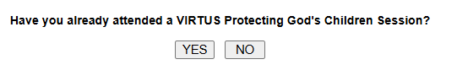
Select the training in English or Spanish. | 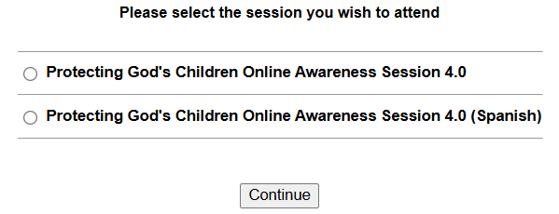
Click on the link in the “Current Training” box to complete your online training. | 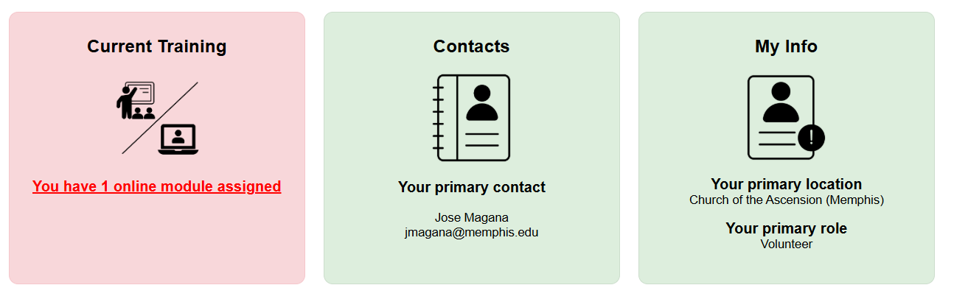
Click on the green circle or the title of the training course to begin the Online Training.  Upon completion, the last screen will allow you to print a certificate, and you will always have the ability to log back into your account and access the certificate.  If you have additional questions about VIRTUS Online training, please contact the local administrator at your parish or school. | 